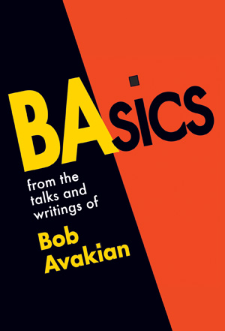
CONSIGNMENT ORDER:

Name of Store______________________________

Address___________________________________

Email_____________________________________

Phone_____________________________________

Contact ___________________________________

# of copies of BAsics left on consignment _____

Terms for ISBN #978-0-89851-007-2:
Cost per copy to stores is $6.00; cover price is $10.00.
Consignment is for a minimum of 30 days.
Payment is expected when volunteer returns to re-stock and/or pick up any copies in good condition which store wishes to return after 30 days.

Signed by store representative________________________________

Date____________

For re-stocking requests or for questions please contact:

[Insert here local Revolution Books, name, address and phone number.]

